**BANK LOAN REPORT QUERY DOCUMENT**

**A.BANK LOAN REPORT | SUMMARY**

**KIP’s**

**Total Loan Applitations**

SELECT COUNT(id) AS Total_Loan_Applications

FROM financial_loan



**MTD Loan Applications**

SELECT COUNT(id) AS MTD_Total_Loan_Applications

FROM financial_loan

WHERE MONTH(issue_date) =12 AND YEAR(issue_date) = 2021



**PMTD Total Loan Applications**

SELECT COUNT(id) AS PMTD_Total_Loan_Applications

FROM financial_loan

WHERE MONTH(issue_date) =11 AND YEAR(issue_date) = 2021



**Total Funded Amount**

SELECT SUM(loan_amount) AS Total_Funded_Amount

FROM financial_loan



**MTD Total Funded Amount**

SELECT SUM(loan_amount) AS MTD_Total_Funded_Amount

FROM financial_loan

WHERE MONTH(issue_date) =12 AND YEAR(issue_date) =2021



**PMTD Total Funded Amount**

SELECT SUM(loan_amount) AS PMTD_Total_Funded_Amount

FROM financial_loan

WHERE MONTH(issue_date) =11 AND YEAR(issue_date) =2021



**Total Amount Received**

SELECT SUM(total_payment) AS Total_Amount_Collected

FROM financial_loan



**MTD Total Amount Received**

SELECT SUM(total_payment) AS Total_Amount_Collected FROM financial_loan

WHERE MONTH(issue_date) = 12



**PMTD Total Amount Received**

SELECT SUM(total_payment) AS Total_Amount_Collected FROM financial_loan

WHERE MONTH(issue_date) = 11



**Average Interest Rate**

SELECT AVG(int_rate)*100 AS Avg_Int_Rate FROM financial_loan



**MTD Average Interest**

SELECT AVG(int_rate)*100 AS MTD_Avg_Int_Rate FROM financial_loan

WHERE MONTH(issue_date) = 12



**PMTD Average Interest**

SELECT AVG(int_rate)*100 AS PMTD_Avg_Int_Rate FROM financial_loan

WHERE MONTH(issue_date) = 11



**Avg DITI**

SELECT AVG(dti)*100 AS Avg_DTI FROM financial_loan



**MTD Avg DITI**

SELECT AVG(dti)*100 AS MTD_Avg_DTI FROM financial_loan

WHERE MONTH(issue_date) = 12



**PMTD Avg DTI**

SELECT AVG(dti)*100 AS PMTD_Avg_DTI FROM financial_loan

WHERE MONTH(issue_date) = 11



**GOOD LOAN ISSUED**

**Good Loan Percentage**

SELECT

(COUNT(CASE WHEN loan_status = 'Fully Paid' OR loan_status = 'Current' THEN id END) * 100.0) /

COUNT(id) AS Good_Loan_Percentage

FROM financial_loan



**Good Loan Applications**

SELECT COUNT(id) AS Good_Loan_Applications FROM financial_loan

WHERE loan_status = 'Fully Paid' OR loan_status = 'Current'



**Good Loan Funded Amount**

**SELECT SUM(loan_amount) AS Good_Loan_Funded_amount**

**FROM financial_loan**

**WHERE loan_status = 'Fully Paid' OR loan_status = 'Current'**



**Good Loan Amount Received**

SELECT SUM(total_payment) AS Good_Loan_amount_received

FROM financial_loan

WHERE loan_status = 'Fully Paid' OR loan_status = 'Current'



**BAD LOAN ISSUED**

**Bad Loan Perventage**

SELECT

(COUNT(CASE WHEN loan_status = 'Charged Off' THEN id END) * 100.0) /

COUNT(id) AS Bad_Loan_Percentage

FROM financial_loan



**Bad Loan Applications**

SELECT COUNT(id) AS Bad_Loan_Applications FROM financial_loan

WHERE loan_status = 'Charged Off'



**Bad Loan Funded Amount**

SELECT SUM(loan_amount) AS Bad_Loan_Funded_amount

FROM financial_loan

WHERE loan_status = 'Charged Off'



**Bad Loan Amount Received**

SELECT SUM(total_payment) AS Bad_Loan_amount_received FROM financial_loan

WHERE loan_status = 'Charged Off'



**LOAN STATUS**

SELECT

loan_status,

COUNT(id) AS LoanCount,

SUM(total_payment) AS Total_Amount_Received,

SUM(loan_amount) AS Total_Funded_Amount,

AVG(int_rate * 100) AS Interest_Rate,

AVG(dti * 100) AS DTI

FROM

financial_loan

GROUP BY

loan_status

Having loan_status IS NOT NULL

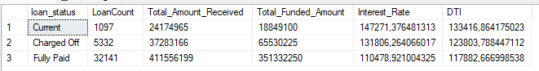

SELECT

loan_status,

SUM(total_payment) AS MTD_Total_Amount_Received,

SUM(loan_amount) AS MTD_Total_Funded_Amount

FROM financial_loan

WHERE MONTH(issue_date) = 12

GROUP BY loan_status

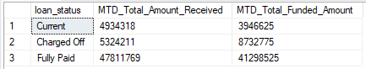

**B. BANK LOAN REPORT | OVERVIEW**

**MONTH**

SELECT

MONTH(issue_date) AS Month_Number,

DATENAME(MONTH, issue_date) AS Month_name,

COUNT(id) AS Total_Loan_Applications,

SUM(loan_amount) AS Total_Funded_Amount,

SUM(total_payment) AS Total_Amount_Received

FROM financial_loan

GROUP BY MONTH(issue_date), DATENAME(MONTH, issue_date)

HAVING MONTH(issue_date) IS NOT NULL

ORDER BY MONTH(issue_date)

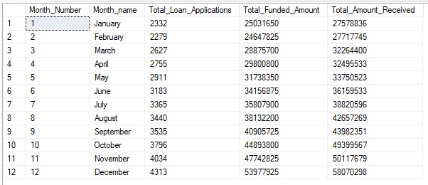

**STATE**

SELECT

address_state AS State,

COUNT(id) AS Total_Loan_Applications,

SUM(loan_amount) AS Total_Funded_Amount,

SUM(total_payment) AS Total_Amount_Received

FROM financial_loan

GROUP BY address_state

ORDER BY address_state

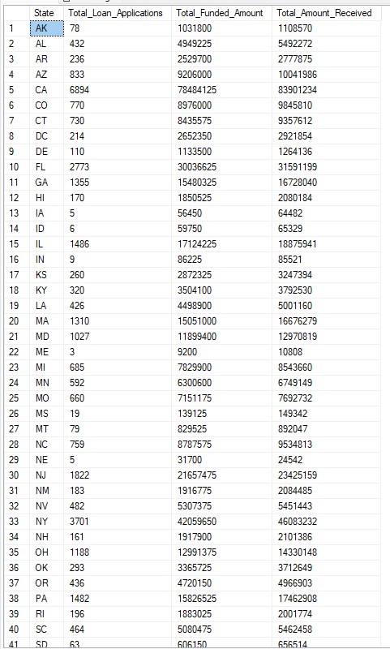

**TERM**

SELECT

term AS Term,

COUNT(id) AS Total_Loan_Applications,

SUM(loan_amount) AS Total_Funded_Amount,

SUM(total_payment) AS Total_Amount_Received

FROM financial_loan

GROUP BY term

ORDER BY term

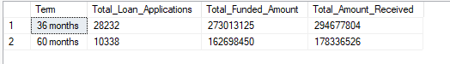

**EMPLOYEE LENGTH**

SELECT

emp_length AS Employee_Length,

COUNT(id) AS Total_Loan_Applications,

SUM(loan_amount) AS Total_Funded_Amount,

SUM(total_payment) AS Total_Amount_Received

FROM financial_loan

GROUP BY emp_length

ORDER BY emp_length

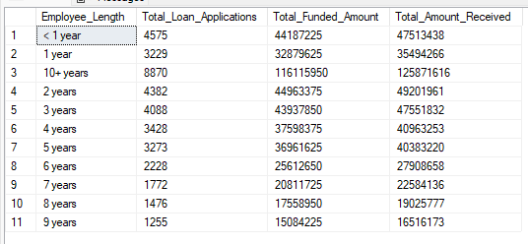

**PURPOSE**

SELECT

purpose AS PURPOSE,

COUNT(id) AS Total_Loan_Applications,

SUM(loan_amount) AS Total_Funded_Amount,

SUM(total_payment) AS Total_Amount_Received

FROM financial_loan

GROUP BY purpose

HAVING purpose IS NOT NULL

ORDER BY purpose

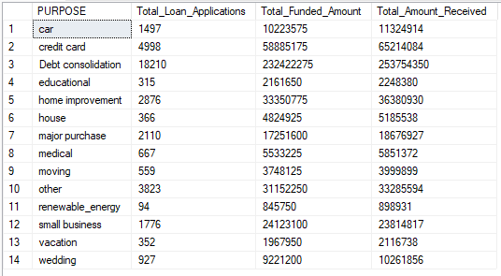

**HOME OWNERSHIP**

SELECT

home_ownership AS Home_Ownership,

COUNT(id) AS Total_Loan_Applications,

SUM(loan_amount) AS Total_Funded_Amount,

SUM(total_payment) AS Total_Amount_Received

FROM financial_loan

GROUP BY home_ownership

HAVING home_ownership IS NOT NULL

ORDER BY home_ownership

